SECTION 2
Testers | qn3 | qn4 | qn5 | qn6 | qn7 | qn8 | qn9 | qn10 | qn11 | qn12 | Average
Mary | 60 | 70 | 70 | 70 | 60 | 80 | 90 | 80 | 90 | 10 | 68
Paul | 70 | 60 | 60 | 80 | 60 | 90 | 80 | 80 | 90 | 30 | 70
John | 100 | 80 | 90 | 100 | 100 | 90 | 90 | 100 | 90 | 100 | 94
Peter | 40 | 20 | 50 | 70 | 60 | 70 | 20 | 50 | 60 | 30 | 47
The Table above has been extracted from the spreadsheet portraying the result obtained from section 2

Analysis statement for SECTION 2.

All the tested persons confirmed to have used the Kiosk App. This is a very positive indication, that the app’s existence is known in the market. The interface provides information that is user friendly as a majority of the interviewed persons suggested that the information provided was easy to understand.
Some of the changes that are required to be made however include, the overall appearance of the user interface. Attractive coloring and more updates with regards to restaurants that are on the verge of growth on daily basis.

SECTION 3
Testers | qn13 | qn14 | qn15 | qn16 | qn17 |  |  |  |  |  | Average
Mary | 3 | 5 | 5 | 5 | 1 |  |  |  |  |  | 3.8
Paul | 2 | 4 | 5 | 5 | 1 |  |  |  |  |  | 3.4
John | 2 | 4 | 5 | 5 | 1 |  |  |  |  |  | 3.4
Peter | 4 | 2 | 3 | 5 | 2 |  |  |  |  |  | 3.2

The table above has been extracted from the spreadsheet portraying the result obtained from section 3.

Analysis statement for SECTION 3
It is essential to underline that, all the four tested persons encountered error messages from the application. Despite that encounter, the messages they received seemed to be of immense help to them as they navigated around the application. It therefore enabled them to act as a result of the occurrence of the error message. Additionally, all the features of the Kiosk App worked according to the individuals tested.
The important bit is that all the users recorded that the Kiosk App did not crash or hang whatsoever during the point of usage.

The table below shows how the data appears under the spreadsheet format. It is a combined data from section 2 and 3
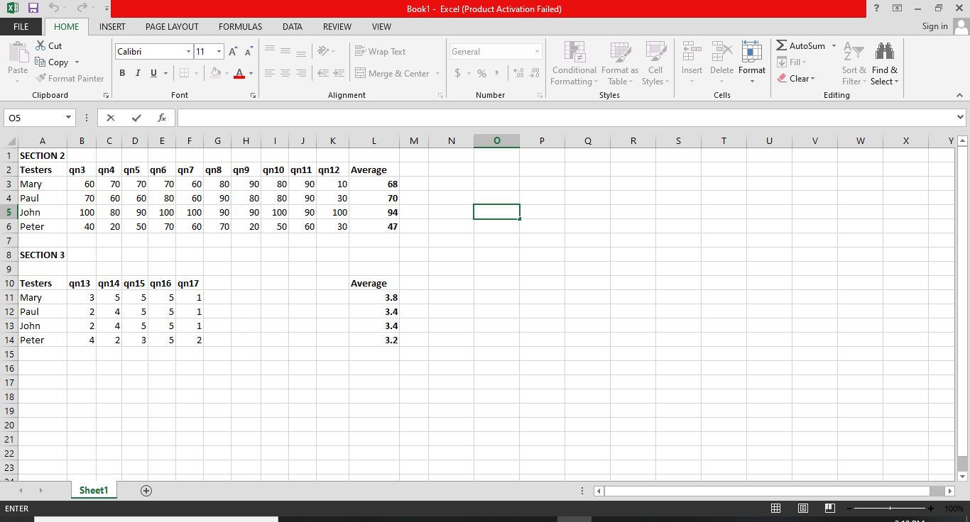

Summary
The awareness on the existence of the Kiosk App is slowly penetrating the market. Test subscribers already show an act of pleasure for the existence of the interface which has immensely proved to be useful in its application. However, the app needs to be modified slightly in terms of appearance. The verdict is that the end consumer is satisfied with the existence of the product.

References
Stone, D. L., & Open University. (2005). User interface design and evaluation.
Lazar, . (2007). Universal Usability: Designing information systems for diverse users. Wiley.

